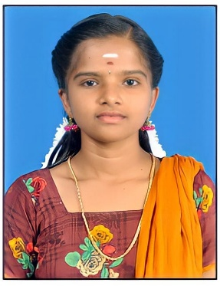RESUME

**R.Gobika**

**D/o S.Ramar**

North Street,

Ayyanarkulam 627853

Alangulam(TK)

TENKASI(DIST).

EMAIL ID : ramargobika28@gmail.com

MOBILE NUMBER : 9578911918

**OBJECTIVE:**

Seeking a challenging position in a reputed organization where I can

learn new skills, expand my knowledge, and leverage my Learnings.

**EDUCATIONAL CREDENTIALS:**

● SSLC 65.6%(2019)

● HSC 77.6%(2021)

● Bachelor of Computer science(2nd year)

(Government Arts and Science College for Women, Alangulam

● Course : PGDCA

**KEY STRENGTH:**

● Improving own learning and performance.

● Good Communication Skill.

● Flexibility in Adapting New Things.

● Good Creative Skill.

**PERSONAL DETAILS:**

Father’s Name : S.Ramar

Date of birth :8th May 2004

Gender : Female

Marital Status : Unmarried

Nationality : Indian

Religion : Hindu

Language known : Tamil & English

**DECLARATION:**

I hereby declare that all the details given below are true to the best of my Knowledge and belief.

Place : Ayyanarkulam signature

Date : 20 Mar 2023 Gobika.R